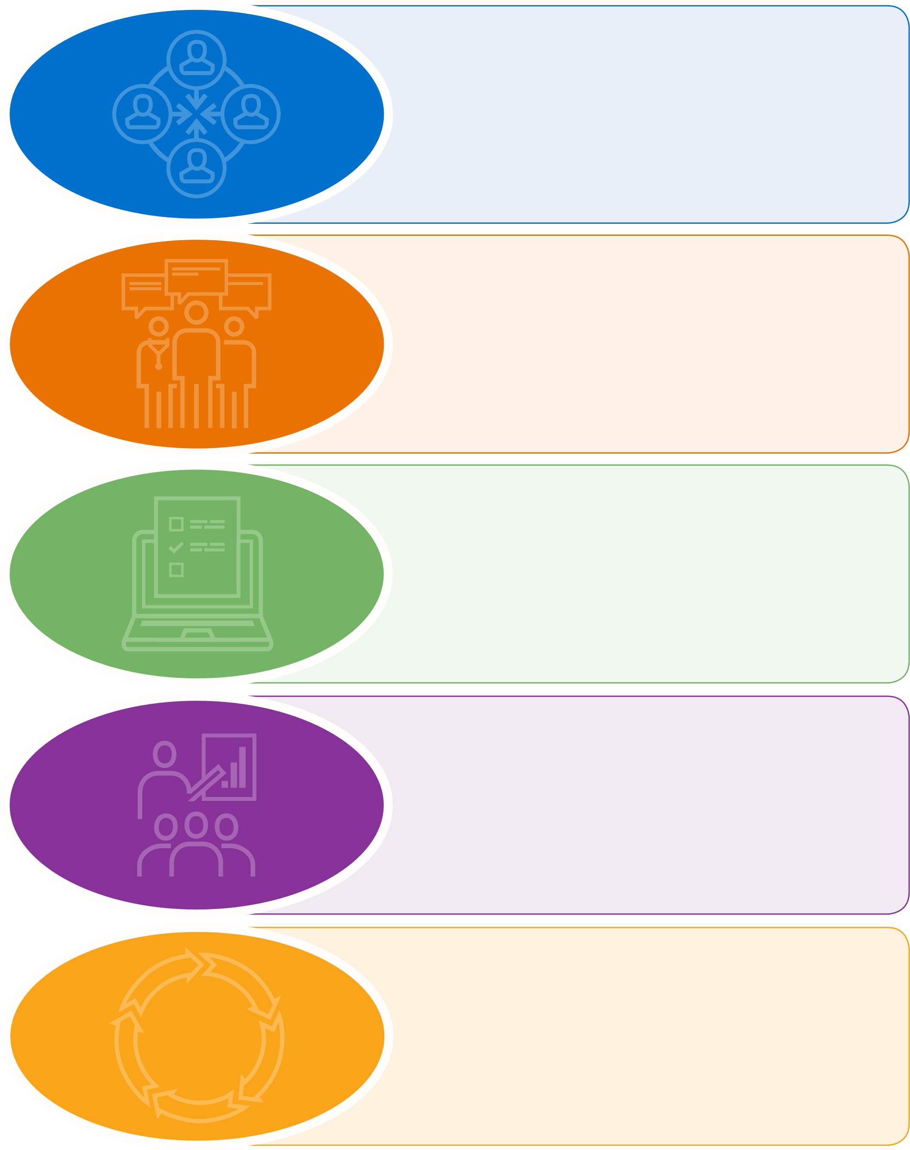

Additional time and effort should go into determining measure development priorities and establishing systems that test and refine measures early in the process

The measure lifecycle should have a “quick path to failure” mechanism whereby measure development would not move forward for non-promising measure concepts or measures for which data collection burden would outweigh the benefits

Priorities for measures should be based on domains or conditions, not clinical settings or programs

Data collection and reporting for quality measures should be standardized

Measure Lifecycle Updates

Measure developers need timely access to data appropriate for testing the scientific acceptability of measures

CMS should support development of additional tools and data sources that would allow measures to be tested as early as conceptualization to ensure measures are meaningful and not unduly burdensome

CMS should support measure developers, for example by promoting development of a toolkit to assist developers with patient and caregiver engagement

Patients and caregivers need to be engaged in all aspects of measure development from priority setting to reevaluation

CMS should support measure developers by fostering collaboration and sharing of best practices (for example, through development of a national testing resource or patient/caregiver engagement toolkit)

CMS should support measure developers by fostering collaboration and sharing of best practices (for example, through development of a national testing resource or patient/caregiver engagement toolkit)

# Figure 1: TEP Recommendations for Adding Value and Efficiency to the Measure Development Process

Meaningful Measures and Transparency in the Measure Process

Stakeholder Engagement and Education

Testing Data and Tools

Collaboration and

Sharing of ~~B~~e~~s~~t Practices